My American Dream Journey

by Loc Huynh

(lightly edited by Sarah Standridge)

I was eighteen years of age when I was on the plane to come to the United States. Growing up in Vietnam, all I knew about the United States was from movies and vague promises of a better life. That did little to prepare me for life in the dream land. All I packed for the journey was naïve confidence, fragment dreams of a better life and 11 years of British English that my mom made me take when I was seven years old. That pretty much set up for a big cultural shock, and I was heading to Arkansas, which I thought it was a name of a city somewhere near Texas.

Arkansas had a very different culture from Vietnam, some of standout differences such as the laid-back mentality, Southern hospitality, and the Southern accent. Despite years of learning English, I could not understand the way people around here spoke, nor could they understand mine. When a family friend came to pick me up at the airport, we literally spoke for ten minutes and that consisted of me trying to repeat the same sentence multiple times and asking him to repeat and slow down. That was my starting point: I came here empty handed, barely spoke the language, but I was determined to create my life here, to become a citizen of this new society and to call the United States my second home.

I knew if I ever wanted to be successful in a different country, I first needed to speak the language. At first, I started out practicing American-English on the Duolingo language app, and binge watching shows on Netflix that had lots of dialogue. After a couple weeks of that, my brother found a link to the website for a literacy program that promoted English conversation sessions with native speakers. It was exactly what I needed, and while it sounded too good to be true, I decided to give this program a try. Shortly after I signed up with Literacy Action, I got in contact with Liz Hawkins, a very kind-hearted woman who was the most patient person in the world I ever met.

Liz and I started meeting twice a week for two hours to practice conversing in English. The goal was to help me build up confidence. She would listen to me attempt to tell a story or talk about any topic that was exciting to me. In addition to that, Liz and her husband, Caley, also suggested different social activities for me participate in as an effort to help my interactive skills. Slowly but surely, I started to gain confidence and improve my verbal communication skills, and not long after that, I started to apply for my first job. With some luck, I got a job at Sonic Drive-In for a cook position, even though I was applying for a cashier at first. Nonetheless, having able to emerge in an environment where I must communicate in English and combining that with tutoring sessions from Liz, my English improved tremendously.

Although working at Sonic helped my communication skills a lot, it was not a very enjoyable job working in a fast-food restaurant kitchen. The first two months were challenging; besides trying my best to communicate at work, I also need to figure out how to get to work and back in the first few months. This was one of those instances when I knew I was blessed with wonderful people in my life as some of my brother’s friends and Liz volunteered to help with the transportation.

Working at Sonic also taught me many life lessons and motivated me to get an education if I want my life to be better. After six months working at Sonic and honing my English communication, I passed the GED and saved up enough money to buy a car. Having all the necessary means, I began my academic career by enrolling for Pulaski Technical Community College in the fall of 2016. My college plan stemmed from my hobbies. I was really into soccer and would love to be a soccer player in an alternative universe, but the dream land could only get you so far. I still wanted to do something that could connect to my hobby. Back in Vietnam, I was excelling in chemistry and math in high school and with the influence from my brother, who was a chemical engineer, so he suggested I should try it out. I decided I wanted to get a chemical engineering degree and work for Nike, a popular soccer apparel manufacturer. In addition to that, if all went well, I could get to experience the university life at the only school in Arkansas to offer chemical engineering major—the University of Arkansas, Fayetteville.

Despite having more exposure to English, my accent was still heavy at this point, and it was nerve wracking to hold a conversation in a larger setup like a college classroom. However, through my learning with Liz, I was confident to speak up, asking questions and patiently repeating myself until I could get my point across. For the next two years at Pulaski Tech, my routine was going to school full-time, English sessions with Liz, and I would squeeze in the time to work part-time and volunteer to further improve my interaction skills. I had better luck with my second part-time job, when I landed a cashier position at Chick-Fil A.

I was determined to make the most out of my education and keep improving my English so that one day I could converse English as if it was my native language. Two years went by so fast, and by my last semester with Pulaski Tech, Liz and I were happy to harvest the fruit of our labor as I was awarded the Academic All-Star Scholarship, with full tuition to transfer to any major university in Arkansas. I impressed the panel of interviewers with my fluent English. I also was awarded the Diversity Advocate for helping to create the school’s first international cultural club. I graduated with an associate degree at Pulaski Tech and with much-improved English, I was ready to finish my bachelor’s degree at U of A.

I still remembered my first day officially being a Razorback. It was the bright sunny day in early fall in 2018. I was walking on the popular Dickson Street toward the engineering department, which hosted most of my classes. Everything seemed to be on a much larger scale compared to community college. I was so excited, I was half-way through making my American dream to come into fruition, but sitting in the lecture hall, I just suddenly realized that I would be competing with more than a hundred bright minds here. I was struggled with transitioning from Pulaski Tech to the University of Arkansas, from general education to actual engineering education. In fact, sophomore and junior years in the chemical engineering program were the toughest time for the students.

The classes were a lot more difficult and aimed to develop basic engineering skills such as critical thinking and problem solving. Another mounting challenge was that the fall semester was also the time when companies looked to fill their vacant internships in the following summer. For engineering students, it goes a long way to have working experiences before graduating. Not only would having an internship help students to develop their engineering mindset a lot quicker, but it also increased their chances to secure a full-time position in the future. Since I only got to the program two months prior to all that, I did not have a chance adapt to these new challenges. The first two months at the university literally took my breath away. Despite how excited I was at the first day of classes, I was filled with so much disappointment and dread. I received failing grades and did not have anything to look forward to next summer.

If people would have asked me to describe myself in one word, I would have said “persistent.” Indeed, my time in the US required a lot of persistence. I was persistent to learn and speak the language, I was persistent to go the University of Arkansas, I was persistent to live my American Dream. Giving up was not an option for me. Just like learning to speak English, I studied harder, put more effort into doing homework, and prepared for the next career fair. That semester I was very devoted. I would wake up at 5:30 AM to start studying, and go to classes with questions I had planned to ask so that I could learn a lot better. When I did not have class, I would squeeze in the time to work part-time or volunteer at the two engineering research groups to gain engineering skills outside of the classroom. In the evening, I would review the same homework I finished in the morning. I was submerged in the engineering bubble at the university. Despite all the hard work, communications were not among my concerns. My time learning with Liz and interacting in different environments helped me a lot along the way. I was able to find opportunities through just simply talking to people in the program and I could make friends in program, which made studying more enjoyable. It was also through those instances that I got a chance to make many life-long friendships.

I started to see the results. My grades improved and I got my confidence back. When I finally got over the steep learning curve, it was a much brighter picture for me. At the end of my first semester, I managed to squeeze out two “B” grades from my two failing classes out of the total 5 classes that I passed. I was also honored to be recognized in a scientific publication from one of my research groups, while the other one had a project that received awards by a regional engineering conference. Most importantly, I was offered an engineering co-op (a three-semester internship) at a chemical manufacturing plant.

I went from one learning curve to another. While getting an internship was already a hard task, working one might even more challenging. In school, there were so many talks about how college was not reflecting the engineering jobs. My internship was the proof of it; engineering skills were expected to be learned on the job. As I recall the first few months at my internship, while I was excited to see how an engineering team would operate, I did not fully understand what was really going on. My technician would ask me some basic technical questions and I would find it hard to come up with an adequate answer. However, like much of everything else, technical knowledge could be learned, and while college could not teach me how to do my internship, it taught me how to understand technical knowledge as well as utilizing resources available to me to solve the problem. I eventually grew into my internship and developed my engineering knowledge, but the moment I felt I was rewarded was when I could communicate with people from different backgrounds on my team about the same technical topic.

As everything was starting to go well for me, COVID happened. It was a big speed bump for my learning experience. While I was lucky enough to keep my internship for the rest of its duration, the learning experience was not the same as the world tried to navigate the “new normal.” Slowing down, I also got the chance to reflect on my journey. After finishing my internship, I would only have one semester left in my program. Having come so close to the crossroads between college and working life, I was overwhelmed with so many questions. The more I learned about engineering, the more I developed different perspectives on my original goals. Since the beginning of my college journey, I was only motivated by one goal: that was to achieve what I set out to do. However, my education and experiences have helped me to understand that being in engineering, I was capable of more than just my goal. Moving away from the tunnel vision that I had developed, I should instead ask myself how I would use my profession to better the welfare of society, to better the life of others and enjoying doing so. That was the question I would need to answer coming back from my internship and my last time as a college student.

Last semester at the University of Arkansas was one of the most difficult things I have done, but it was also a semester of celebration as many plans had come to fruition. I had been living in the United States for five years. For immigrants it was a big milestone, as I was eligible to become the citizen of the free world. Despite the pandemic preventing my family and friends from attending the naturalization ceremony, it did not take away the surreal experience for me. I felt immensely proud when I took the Oath of Allegiance, to call myself a citizen of the United States. It was a celebration for every hard work I have done to establish myself from home away from home. It was also the beginning of a new chapter in my life.

The big celebration of the first chapter of my American life also came with a bigger challenge, finishing my program. For students in chemical engineering to graduate with Latin (honor) distinction, we would participate in a regional contest hosted annually by New Mexico State University to help tackle environmental problems posed to that specific industry. The students needed to propose a solution and demonstrate the experiment as proof that the solution could work while providing a blueprint that the solution can work on industrial scale. We had three months to come up with a solution. It was the longest three months of my life. On top of working around the clock for the project, I also juggled five classes to graduate and needed to confront the reality of employment come May. Not only did my team stumble on a lot of roadblocks to find the solution that was realistic for the project, but we also had to plan it out with the restrictions on COVID safety. We spent so many hours on the project. It was even more unfortunate when Arkansas was hit with a winter storm in February. That set us back one week. I recalled when the winter storm passed, we had to work eighty hours a week for three consecutive weeks and my best friend told me one time that we would see each other more than he saw his fiancé. While it was a challenging time for me, I made a lot memories working on project with my closest friends in the program. It was also during the time working on the project that I started to find out the answer for my career questions. Each member of the team needed to wear different hats during the project from accounting, to logistics, to preparing experiments. Having exposure to the different aspect of engineering, I learned to understand my ability better and which area of engineering that I thrived in. It was the designing aspect of the engineering job, to put the project on blueprint, to create solutions and anticipated problems along the way that gave me the most rewarding feeling. While I was happy to know what I wanted, it was only half of the answer. I still need to find the companies that would offer such job.

Staying on top of my senior project and classes had consumed a lot of my time, resulting in little time to prepare for the spring career fair. Since COVID prevented a lot of companies from hiring and the whole event took place virtually, I had thought to myself that I would just try to look for a position first to get a foot in the door or would try my luck again in the summer. I talked to at least fifteen companies that day, but none of them made me excited about the position they were offering, nor did I impress the recruiters enough to give me a chance to interview. When I was about to log off my computer and go back to studying, I decided to go talk to one last company and I saw the logo of CenterPoint Energy. For some reason, in the previous career fairs, I had always skipped talking to this company. Either the line was too long, or I heard someone said they were only looking for civil and mechanical engineering majors, and since the company business was natural gas, I was not excited to go into the dying oil and gas industry. However, after the conversation with the recruiter, I could not be more wrong. CenterPoint, while working with natural gas, does not produce them, and the main function was to design infrastructure to supply the natural gas safely to consumer. That was exactly what I have always wanted to do. Even better, I got along very well with the recruiter from the company and before I knew it, I got an offer with the company.

By April, it was like I woke up after a big winter storm, and my headaches slowly got resolved. The senior project yielded great results and my team got first place. I accepted the position with CenterPoint. I finished my semester with a 4.0 GPA and graduated with the honor distinction and with the cherry on top, I was the groomsmen for my best friend’s wedding. It was finally a happy ending for my first five years in the United States.

As I was writing through these paragraphs, I had a chance to sit down and reflect on my journey. Coming to a different country and creating a life for myself, I got an engineering career and made life-long relationships. Many of those things I did not even dare to dream of when I first arrived here. I could not stop wondering, what if I decided not to try out English lessons with Literacy Action, how different my life would be!? It all started with a simple goal—I must speak the language. The day I met with Liz I was a pivotal moment in my journey. Without the help from Liz and Caley, I would not have had the chance to improve my English in such quick time and learn about American culture. Without developing my communication, none of my achievements would have been possible. Liz and Caley have done a lot more than just volunteering for the Literacy Action program, they helped realize an American dream for an immigrant. While I am still always learning English and will be improving it for the rest of my life, Liz and Caley have given me an important thing, a starting point for my learning journey.

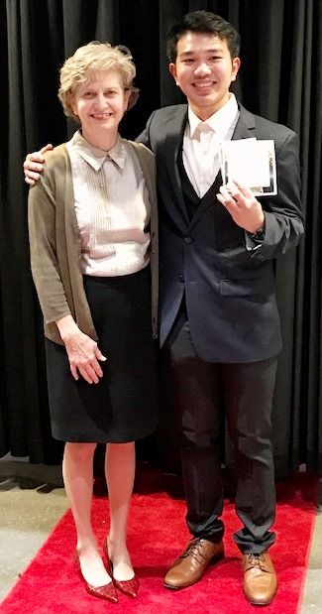

Loc with his tutor, Liz Hawkins

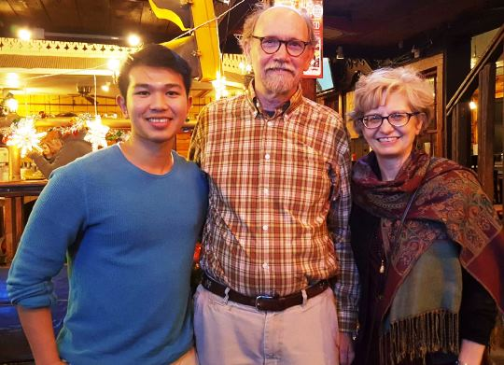

Loc with Caley and Liz Hawkins

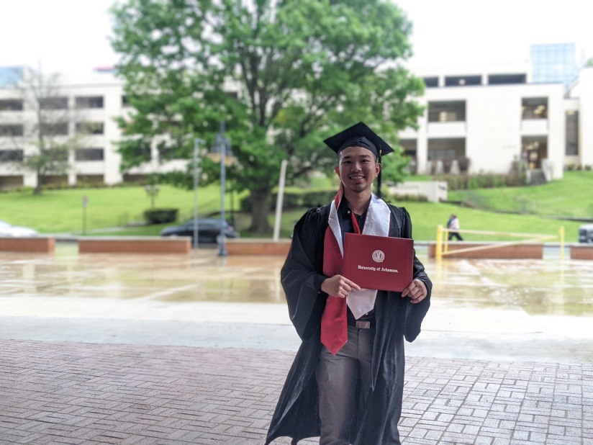

Loc at his U of A graduation

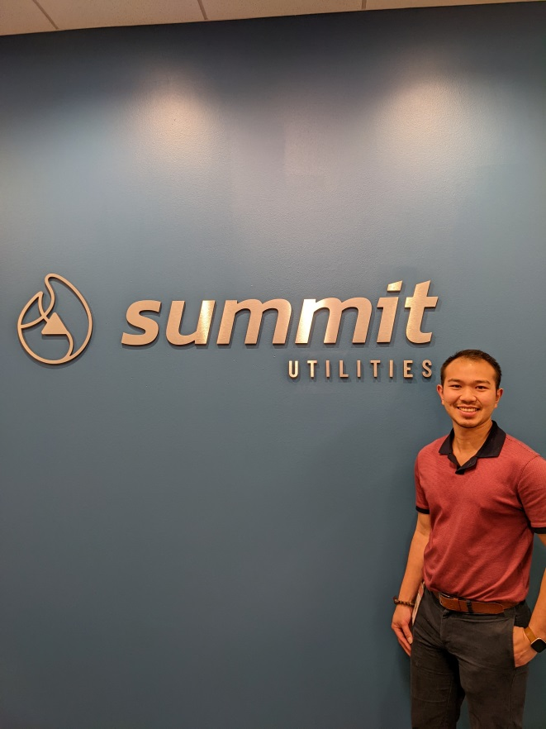

Loc at his first engineering job